CSS DOCUMENT
Topic : Selectors

Selectors are the medium which are used to link html tags with css properties. There are different ways to select and apply properties to html tags using css thats are:

- Universal Selector : It target all elements on the web page and it is used in css by using (*) symbol.

- id Selector : In id selector all html tags which use css must specified with a property called “id ” which holds an id name to be used as selector in css preceded by the help of “#” symbol.

- Class Selector : In id selector all html tags which use css must specified with a property called “class ” which holds a class name to be used as selector in css preceded by the help of “.” symbol.

- Element Selector : If the css codes are applied to html by the help of html tags name as a selector then it is called as element selector. So here html tags are called element selectors.

- Descendent Selector : It’s working flow is like parent to child and it selects all the elements either it present on direct position or in nested position of a specified elements.

- Child Selector : It is also having the same flow as descendent selector but it is only select all the children of a specified elements.

- General Sibling Selector : It selects all the elements that follow the first element that both are the children of same parent.

- Adjacent Sibling Selector : It selects the adjacent sibling of an element. It is used to select only those elements which immediately follow the first selector.

HTML Code:
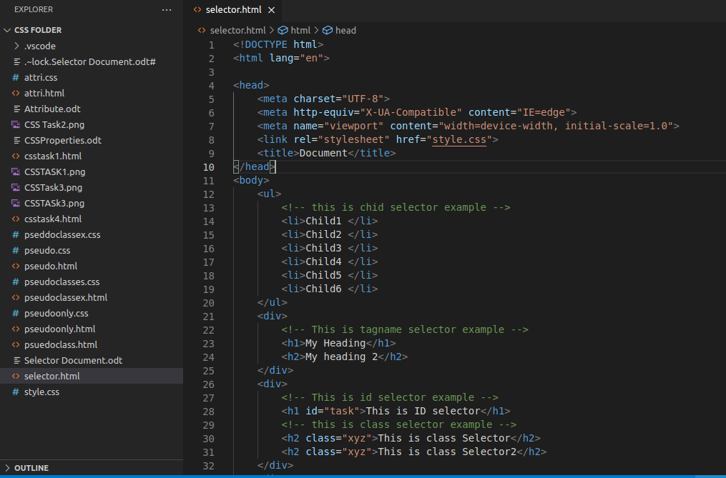
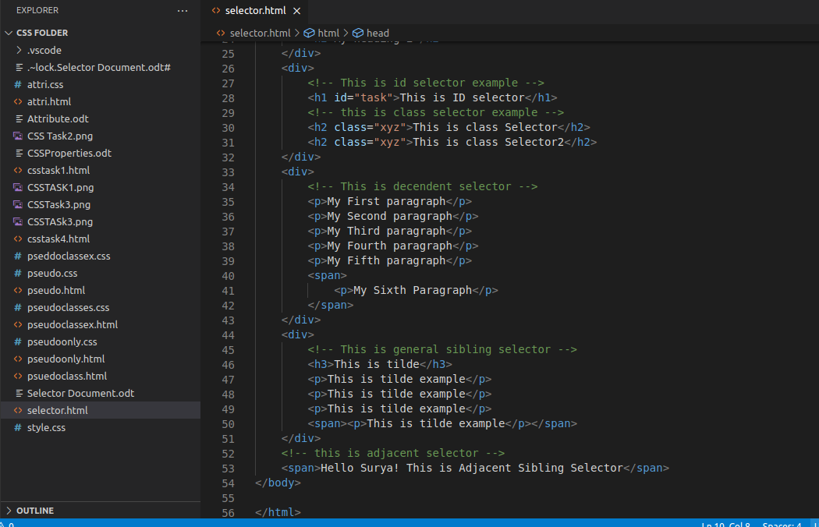

CSS Code :

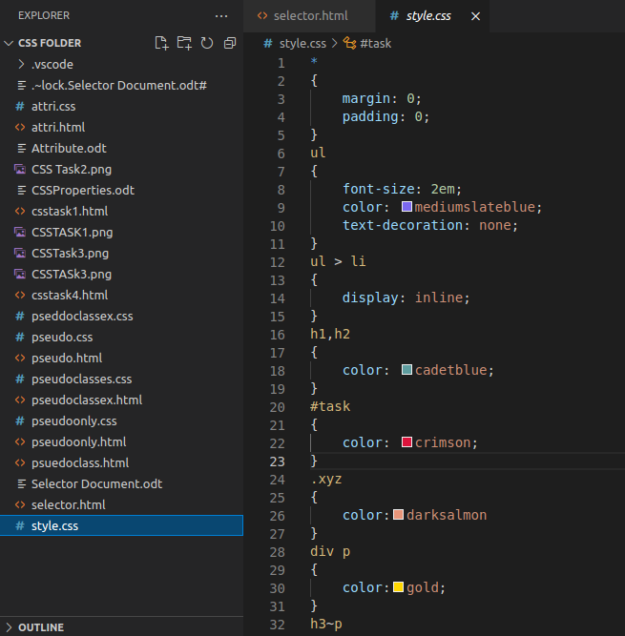

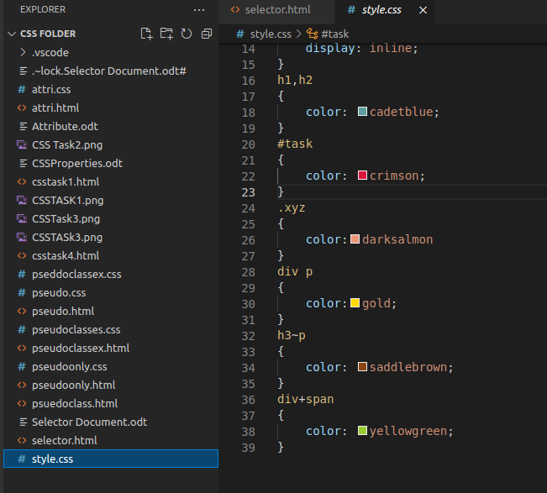

Screenshot :

